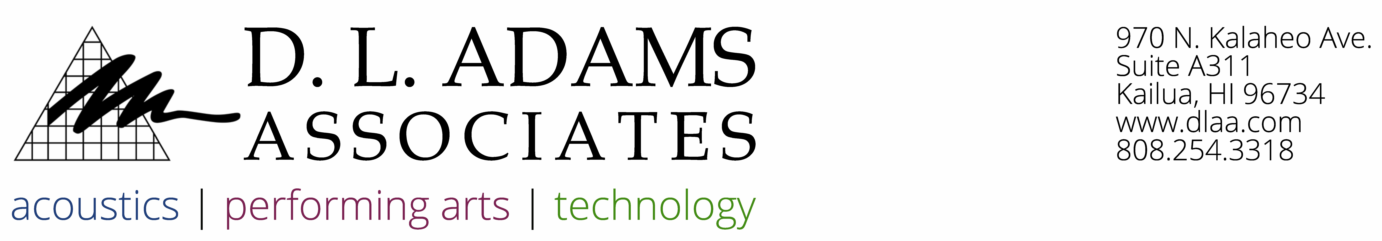

January 10, 2024

Jason McCullough

Gentry Builders, LLC

733 Bishop Street, Suite 1400

Honolulu, HI 96813

**RE: Ka’ulu by Gentry ASTC-AIIC Testing - Acoustical Testing Services Proposal (DLAA# P24-004)**

Jason,

Thank you for the opportunity to propose our acoustical testing services for the Ka’ulu by Gentry project in Kapolei, Hawaii. Based on your email dated January 5, 2024, we understand you are requesting acoustical testing of floor-ceiling assemblies in multifamily townhomes. We have prepared the following scope of Basic Services and Compensation for your consideration.

**BASIC SERVICES**

Acoustical Testing Services

Acoustical testing will be conducted on a total of four (4) floor-ceiling assemblies.

1. Conduct Apparent Sound Transmission Class (ASTC), and/or Noise Isolation Class (NIC) tests. These tests will be conducted in general accordance with ASTM E336-17a, *Measurement of Airborne Sound Attenuation between Rooms in Buildings.* Conduct Apparent Impact Insulation Class (AIIC) tests. These tests will be conducted in general accordance with ASTM E1007-16, *Field Measurement of Tapping Machine Impact Sound Transmission Through Floor-Ceiling Assemblies and Associated Support Structures.*
2. Calculate the ASTC performance of the assemblies from the measured sound pressure levels in accordance with ASTM E336 and ASTM E413, *Classification for Rating Sound Insulation.*  Calculate the AIIC performance of the floor-ceiling assemblies from the measured impact sound pressure levels in accordance with the procedures of ASTM E989-06 (2012), *Standard Classification for Determination of Impact Insulation Class (IIC).*
3. Provide a written report of the test results. The report will include all test results together. The report will be an "abridged" version of the ASTM test report which includes a summary of the test procedures and results. A complete ASTM compliant report can be provided, if needed, for an additional fee. Abridged reports are offered as a cost savings measure, and still include detailed results.

Testing will require one full day of access to the units being tested. To avoid delays to the testing procedure, no other noise producing activities will be allowed during the tests, including construction, maintenance, exterior work, etc. Further, we advise limiting the number of personnel present during the tests to only those required to provide access to DLAA. The client is responsible for coordinating the appropriate days which meet these criteria.

Should DLAA be required to return on a second day to complete testing due to delays arising from access issues or interferences from noisy on-site activity, additional fees will be incurred for each additional day at a rate of $3,200.00 per day.

**ADDITIONAL SERVICES**

The following Additional Services are not included in the scope of Basic Services but can be provided, if requested, for a mutually agreed-upon fee.

1. Site visits beyond those listed in the Basic Services above.
2. Additional tests beyond those included in the Basic Services.
3. Any other service not explicitly described in the Basic Services above.

**COMPENSATION**

D.L. Adams Associates, Ltd. proposes to provide the scope of Basic Services for a lump sum fee of $10,300.00. This fee includes all labor, non-labor expenses, and Hawaii GET.

The fees proposed for this work will be honored for 6 months from the date of this proposal. After 6 months, fees may need to be renegotiated.

It is our policy to obtain a retainer for projects with new clients. We will require a retainer of $1,000.00 before commencing work on the project. This retainer will be applied to the final invoice issued. Receipt of the signed enclosed Consultant Agreement and retainer will serve as our notice to proceed with this work.

Please feel free to call if you have any questions or wish to discuss this proposal. We look forward to working with you.

Sincerely,

Jake Pfitsch

Staff Consultant

Encl.: Consultant Agreement